Initial Requirements Gathering
(Version 1.0)
Team-5

CONTENTS

- Importance of Initial Requirements..........................................3
- Modes Conducted for Requirements Gathering.......................3
- Questionnaire............................................................................4
- Interviews.................................................................................5
- Answers Statistics.....................................................................6
- Conclusion................................................................................7

Importance of Initial Requirements Gathering
The initial requirements gathering play one of the most important phases in requirements gathering phase which guides a software development team in development of the software. Though it can be quite intensive and difficult sometimes but it is an important part. The initial requirement gathering conveys the team about what the targeted audience/user thinks of the problem statement/situation. The requirements gathering can be done by various ways. The mode of requirement gathering also depends on the size of target audience. From the requirements gathered the team can understand the user requirements, user mentality and knowledge level. The exact requirements will lead the team to make fewer mistakes in software development. The requirements gathering are a part of requirements study that is followed by requirements analysis. The output followed is a SRS (System Requirements Specifications) document. Though the documents followed after the requirements study are more than one, but the most important document is SRS.

Modes conducted for Requirements Gathering
The modes conducted for requirements gathering by the team are following:
- Interviews
- Feedback forms
The feedback forms were distributed to the students of DA-IICT. Approximately 31 forms were filled by students. And the forms filled were analysed & statistics were developed. A statistics document was then prepared. Interviews were conducted by team members for the faculty members. Prof. Rahul Muthu & Prof. Jaideep Mulherkar were interviewed. A batch mate Khushboo Tekchandani from DA-IICT was also interviewed.

Questionnaire
Given below is the questionnaire that was given to the students of DA-IICT.
Q1) How often do you check your webmail?
- More than once a day
- Once a day
- Once a week

Q2) Have you ever faced a problem for not having checked your webmail on time? (For instance, missing a deadline)
- Yes
- No

Mention the problems you have faced:

Q3) Would you like an SMS notification for webmail?
- Yes
- No
Please mention the reasons for your answer________________________________
__________________________________________________________________________

Q4) Are you using a similar facility for other web accounts like Gmail, etc.?
- Yes
- No

Q5) Would you like a filter for the SMSs that you receive?
- Yes
- No

Q6)What would like the mails to be filtered on the basis of? ( you can give multiple answers)
- Sender
- Subject
- Other _________________________________________________________

Q7) What kind of features would you like? ( you can give multiple answers)
- Enable/Disable feature
- Enable for certain duration of the day only
- SMS for task reminder
- Any other feature you would like to have: _____________________________________

Q8)Do you think there should be quota on the number of SMSs that a user can receive?
- Yes
- No

Q9)Are you ready to pay extra if you quota exceeds?
- Yes
- No

Q10) Expectations from the application: __________________________________________
_______________________________________________________________________________________________________________________________________________
Thank you for your valuable response.
Team-5

Interviews
As mentioned above, the persons whose interviews were taken are mentioned in the section above. Given below are the detailed interviews of the personnel.
Interview 1:
Interviewer: P.N.V.S Ravali, Hetaswi Vankani
Interviewee: Prof. Rahul Muthu
Date: 10th February, 2011
Time: 2:30 p.m.
Duration: 30 mins
Venue: Faculty Block 1

The interviewee stated that he does face problems related to missing deadlines etc and that the sytem under consideration would be useful to him. Previous alert systems like that offered by gmail have not been used by him. The stakeholder asked for disabling and enabling features both temporary and permanent. Filtering based on paired messages i.e., if a message exists in the outbox only then should a notification be sent to the user (It is to say that the notification for only those mails should be received that are sent in response to the user's mail). The interviewee was in full support of the institution providing facilities and funding for the project as it is in the benefit of the students. The stakeholder was willing to pay extra sum for the facility.

Interview 2:
Interviewer: P.N.V.S Ravali, Hetaswi Vankani
Interviewee: Prof. Jaydeep Mulherkar
Date: 10th February, 2011
Time: 3:30 p.m.
Duration: 30 mins
Venue: Faculty Block 1
The interviewee stated that he does not face problems related to missing deadlines, etc. However, he would like to have a task reminder system that could be integrated to the calendar on webmail and an SMS be sent for the same. Previous alert systems like that offered by gmail have not been used by him. The stakeholder asked for disabling and enabling features both temporary and permanent.
Filtering based on subject and sender. He would like to be informed primarily about the subject and the sender in the message. The application should send the entire message if the user sends some SMS back asking for the entire message retrieval. The interviewee was not willing to pay extra sum for the facility.

Interview 3:
Interviewer: P.N.V.S Ravali
Interviewee: Khushboo Tekchandani
Date: 10th February, 2011
Time: 8:00 p.m.
Duartion: 40 mins
Venue: Women's HOR

The interviewee stated that she does face problems of missing deadlines, etc. She said that the front end should have a tab that would provide for SMS settings. The stakeholder demanded a feature that would inform her when half the quota of SMS is completed. When the user comes to know that half the quota has been finished, there would be an option of recieving messages for mails marked urgent.

Answers Statistics
A bar graph and statistic table is given below specifying the distribution of answers by the potential users who were questioned.

Questions | Q1 | Q2 | Q3 | Q4 | Q5 | Q6 | Q7 | Q8
Option1 | 24 | 19 | 18 | 10 | 24 | 20 | 8 | 5
Option2 | 2 | 7 | 8 | 17 | 2 | 10 | 18 | 21
Option3 |  |  |  |  |  | 12

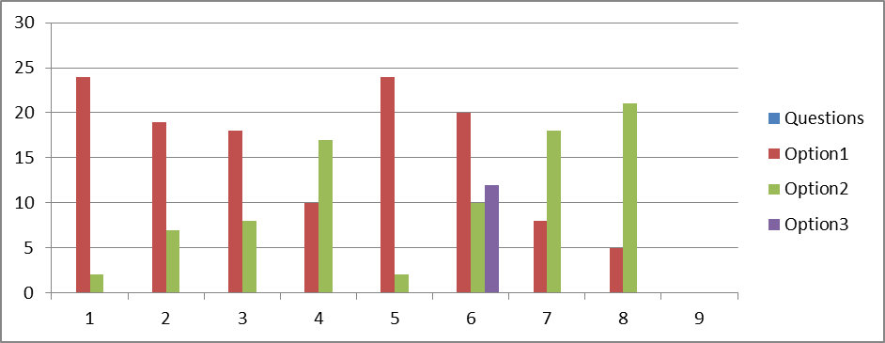

CONCLUSION
Seeing the response of many students via the questionnaire and the statistical study of the answers that have been given, following conclusions can be drawn:
- It seems there is a lot of enthusiasm amongst the students for our project, seeing the usefulness of the feature in their everyday life in institute.
- Most of them have this habit of checking their webmail accounts more than once a day; still they wanted this feature of receiving a notification for an unread mail to be implemented in their account as most of them have faced the problem of missing the deadline.
- Though it was quite a positive and enthusiastic reaction from students side most of them were not willing to pay extra money for exceeding quota, which is not a big issue seeing a fact that on an average a student never receives more than 1500 mails per year or one more thing which can be done is that we can increase the quota.
- Almost all of them wanted an extra feature of being able to enable/disable this facility so as to make this facility much more flexible and easy to use.
- Some of them even thought that getting a sms for reminders that have been set would be a useful feature.
- Asking for what they think should also be included in the application, most of them wanted to be able to block SMS’s by selecting it on the basis of user or subject or both.

